ANNIVERSARY DECORS

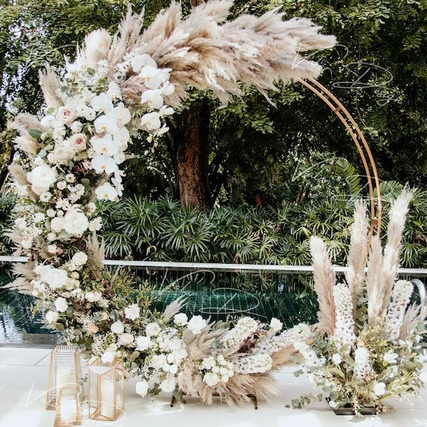

Floral decoration on anniversary is the art of adorning anniversary venues with a carefully curated selection of flowers, greenery, and other botanical elements to create a romantic and visually stunning ambiance. It involves the strategic placement of floral arrangements, bouquets, centerpieces, and other botanical accents to enhance the overall aesthetic and theme of the wedding.

The selection of flowers plays a crucial role in anniversary decor, with couples often choosing blooms that hold special significance or align with their wedding color palette and theme. From classic roses and elegant lilies to whimsical peonies and exotic orchids, the possibilities are endless, allowing couples to express their unique style and personality through décor.